
Sukkur IBA University

Department of Computer Systems Engineering

Object oriented Programming (OOP) Course
INSTRUCTOR: Engr: Zainab Umair

PROJECT REPORT ON

ATM Simulator System
A Comprehensive Java & MySQL Project

Group Members: CMS-ID
- Pirbhu ji Rajput 133-24-0012
- Abdul Saboor Memon 133-24-0003

Certificate
The project report entitled “ATM Simulator System: A Comprehensive Java & MySQL Project” Submitted by Students of BE-Computer System Engineering (CSE-II) has carried out the necessary work of Object-Oriented Programming and Database Management as per course requirements. It is submitted to the Computer System Engineering Department, Sukkur Institute of Business Administration for Fall-2025.

ACKNOWLEDGMENTS
I would like to express my deepest gratitude to our respected instructor, Engr: Zaniab Umair, for their continuous guidance, support, and motivation throughout the development of this project. Their valuable insights and feedback were crucial in shaping the Object-Oriented Design (OOP) principles and ensuring the robust MySQL integration of the ATM Simulator System.
Furthermore, I am thankful to my dedicated team members, Abdul Saboor Memon, for their cooperation, coordination, and active participation in every stage of the project.
Finally, I would like to extend our heartfelt thanks to all those who contributed their help and resources through social media and various online platforms. Their valuable assistance was instrumental in the successful execution and completion of this work.

1. INTRODUCTION
This report details the development of a fully functional ATM Simulator System, a project designed to demonstrate proficiency in Java (Swing GUI), MySQL database management, and Object-Oriented Programming (OOP) principles. The simulator provides a realistic, secure, and user-friendly interface for common banking transactions, including account creation, login, deposit, withdrawal, balance inquiry, PIN change, and mini-statement generation.
The core goal of this project was to replicate the complex, secure operational logic of a real-world Automated Teller Machine (ATM) in a software environment, ensuring strong data validation and adherence to industry-standard banking protocols for transaction logging and data integrity.

2. SYSTEM ARCHITECTURE AND TECHNOLOGY STACK
The ATM Simulator employs a robust Two-Tier Architecture, which promotes scalability and the clear separation of concerns, critical for financial applications.
Component | Technology | Role
Frontend (GUI) | Java Swing | Provides the interactive, user-friendly interface for all ATM operations. Handles user input and displays transaction results.
Backend (Logic) | Java (OOP) | Contains the business logic, transaction processing, data validation, and error handling.
Data Layer | MySQL | Stores all persistent data: user credentials, account details, and a complete audit trail of transaction history.
Connectivity | JDBC (MySQL Connector/J) | Facilitates seamless communication between the Java application (Backend) and the MySQL database (Data Layer).

3. OBJECT-ORIENTED DESIGN (OOP) IMPLEMENTATION
The project is structured around a clean, modular, and extensible OOP design, which ensures the codebase is maintainable and easily debuggable.

3.1. Key OOP Concepts Utilized
- Inheritance: An abstract base class, ATMFrame, is used as a template for all GUI screens (Login, Signup, Dashboard, etc.). This class extends JFrame, initializes the database connection (DatabaseConnection), and establishes a common look-and-feel, ensuring consistency across the entire application.
- Encapsulation: The DatabaseConnection class centralizes all MySQL connection details, transaction logic (e.g., executing queries), and resource management. By hiding the complex database implementation details, this class provides a secure and single point of access to the data layer.
- Polymorphism: Each unique screen (e.g., Deposit, Withdrawal, PinChange) extends the base ATMFrame and overrides methods like setupUI() and actionPerformed(). This allows each screen to implement its own unique functionality while inheriting the standard properties and database connection handler from the base class.

4. DATABASE SCHEMA DESIGN
The system uses three normalized tables, designed to ensure high data integrity, transactional reliability, and a complete audit trail.
Table Name | Primary Key | Key Fields | Purpose
login | card_number | card_number, pin | Stores credentials for quick authentication lookup.
accounts | accno | accno, cardno (Unique), name, balance, pin | Stores core account details, current balance, and is the source of truth for financial status.
transactions | id (Auto-Increment) | cardno, type, amount, date_time, balance_after | Logs every financial operation (DEPOSIT, WITHDRAW, FASTCASH), crucial for auditing and statement generation.

5. CORE FUNCTIONALITY IMPLEMENTATION
The application implements all standard ATM services, with rigorous validation checks embedded in the backend logic.

5.1. Account Creation (Signup Page)
The signup process includes rigorous validation to ensure data integrity and prevent fraud:
- Format Validation: Strict checks are performed on all fields:
  - Account Number: Must be exactly 11 digits.
  - Card Number: Must be exactly 14 digits (used for login).
  - PIN: Must be exactly 4 digits.
  - Name: Must contain only letters and spaces.
- Uniqueness Check: The system queries the database to confirm that the Account Number and Card Number are not already in use before proceeding.
- Data Insertion: On successful validation, records are simultaneously inserted into both the login and accounts tables. An initial DEPOSIT transaction is logged to establish the starting balance.

5.2. Financial Transactions (Deposit, Withdrawal, Fast Cash)
All financial operations follow a secure, three-step transaction protocol:
- Input Validation: Check if the amount is numeric, positive, and adheres to transaction limits.
- Critical Check (Withdrawal Only): The system fetches the current balance and performs a critical check for Insufficient Balance. If the available balance is less than the requested withdrawal amount, the transaction is rejected.
- Account Update & Logging: If the checks pass, the balance field in the accounts table is updated (increased for deposit, decreased for withdrawal). Simultaneously, a detailed record is immediately inserted into the transactions table, including the transaction type and the balance_after the operation, guaranteeing an immutable audit trail.

5.3. Utility Functions
- Balance Enquiry: Retrieves the current balance from the accounts table and displays it instantly. This is a read-only operation.
- PIN Change: This secure function requires the user to first enter the old PIN for verification. If successful, the new 4-digit PIN is updated across both the login and accounts tables to maintain consistency. For security, the user is then redirected back to the login screen.
- Mini Statement: Retrieves the last 10 transactions from the transactions table for the logged-in user, displaying the date, time, type, amount, and resulting balance after each operation.

6. TECHNICAL IMPLEMENTATION AND SETUP

6.1. Prerequisites
- Java Development Kit (JDK) Version 8 or higher.
- MySQL Server (Installed and Running).
- MySQL Connector/J (JDBC driver for connectivity).

6.2. Database Setup
The database, named atmsimulator, must be created, and the three schema tables (login, accounts, transactions) must be executed using the provided SQL script (atm_schema.sql). The Java application is configured to connect to jdbc:mysql://localhost:3306/atmsimulator with the default development credentials.

6.3. Key Features Implemented
Feature | Description
Login System | Validates 14-digit card number and 4-digit PIN against the login table.
Signup Page | Creates new accounts with rigorous format and uniqueness validation; initializes balance and logs the first transaction.
Dashboard | Main menu providing access to all transaction and utility options.
OOP Design | Uses ATMFrame abstract base class and separate, modular classes for each screen.

7. CONCLUSION AND FUTURE SCOPE

7.1. Conclusion
The ATM Simulator System successfully meets all the project requirements, delivering a robust and fully functional application. The project demonstrates a strong integration between the Java Swing GUI and a MySQL backend, built upon solid Object-Oriented Programming principles. The result is a well-structured, maintainable, and scalable codebase with a persistent, reliable data storage solution, making it a complete and realistic representation of a modern ATM system.

7.2. Future Scope
While the current system is fully operational, several enhancements could be implemented to expand its capabilities:
- Enhanced Graphics: Replace current placeholder images with a more realistic, graphical ATM interface.
- Advanced Features: Implement fund transfer between accounts and bill payment functionality.
- Modernization: Migrate the frontend from Java Swing to a more modern framework like JavaFX or develop a web-based frontend using Spring Boot.
- Advanced Security: Incorporate advanced security measures such as password hashing/encryption and two-factor authentication (2FA).

8. REFERENCES
- OOP Lecture Notes (From the Object-Oriented Program (OOP) Course).
- Java Documentation (Oracle/OpenJDL): Official documentation for core Java concepts, syntax, and libraries (Java Swing GUI).
- MySQL Official Documentation: References for database installation, management, SQL queries, and the implementation of the database schema.
- Online Resources and Tutorials: Used for specific implementation details regarding JDBC (Java Database Connectivity) and two-tier architecture design.

9. Screenshots

Screenshot 1 – Login Screen
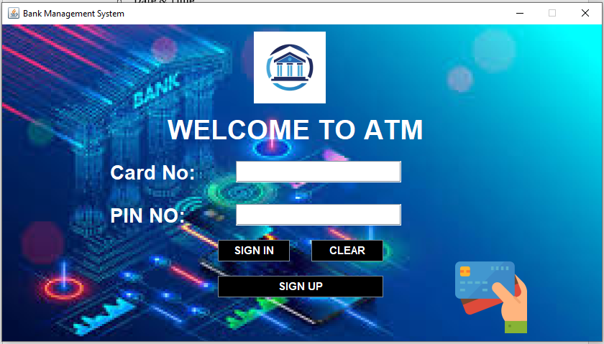

Screenshot 2 – SignUp Screen
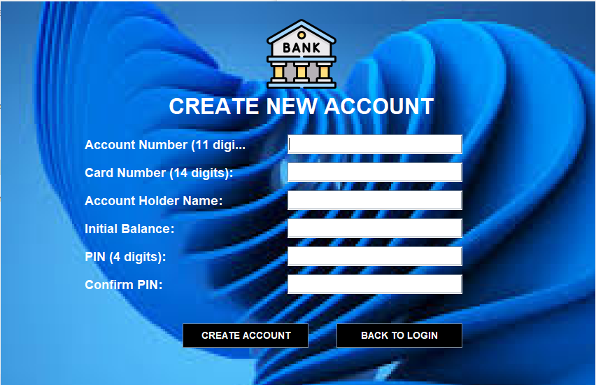

Screenshot 3 – Dashboard Screen
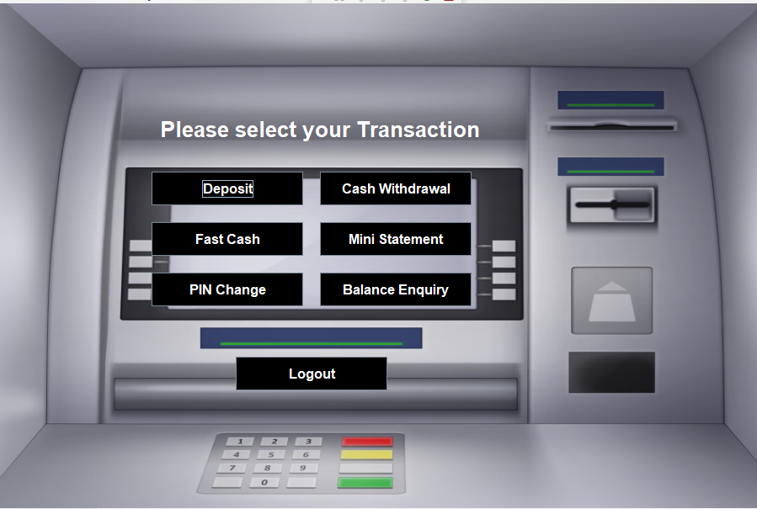

Screenshot 4 – Deposit Window

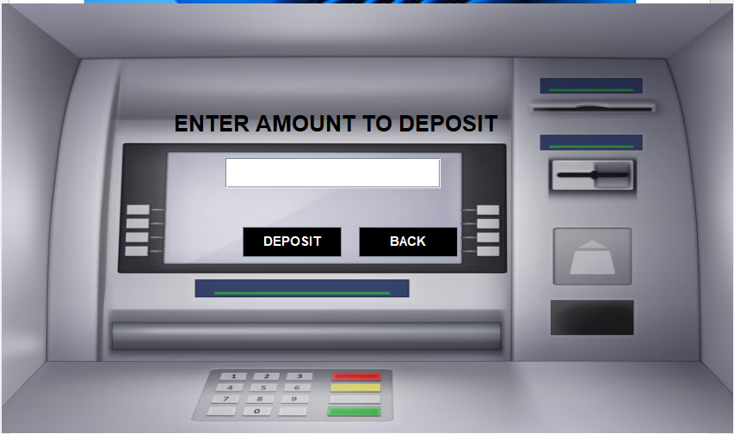

Screenshot 5 –Withdraw Window

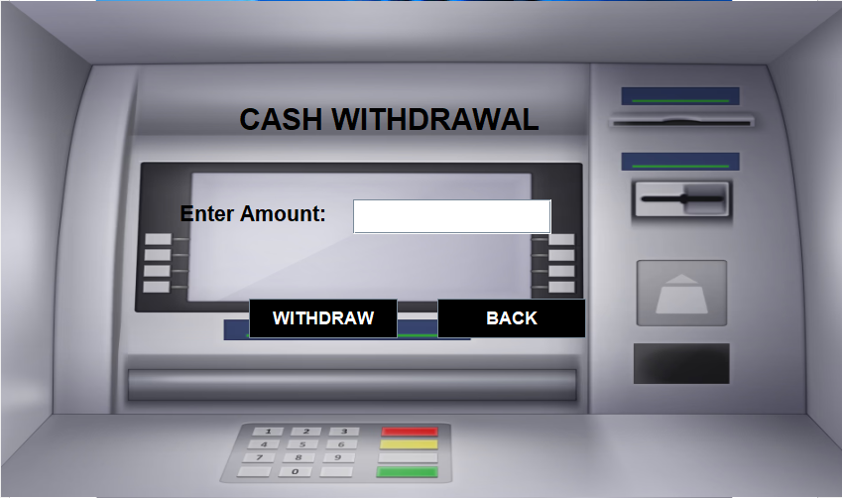

Screenshot 6 –Fast Cash Window
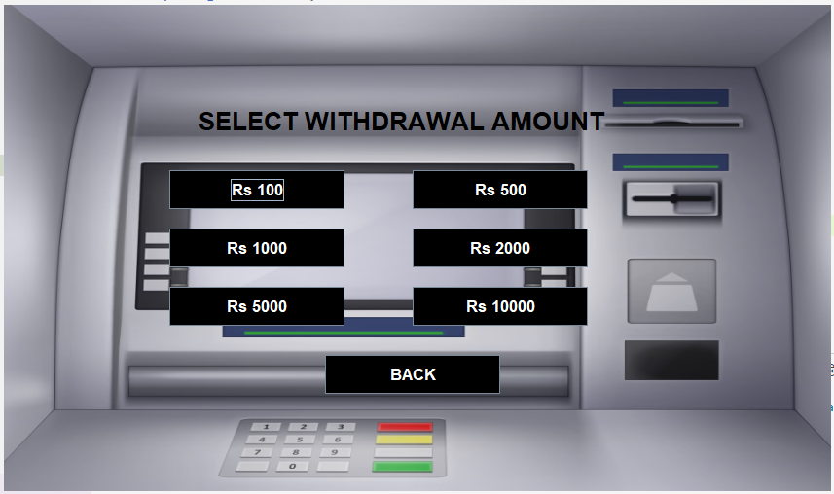

Screenshot 7 –Mini Statement Window
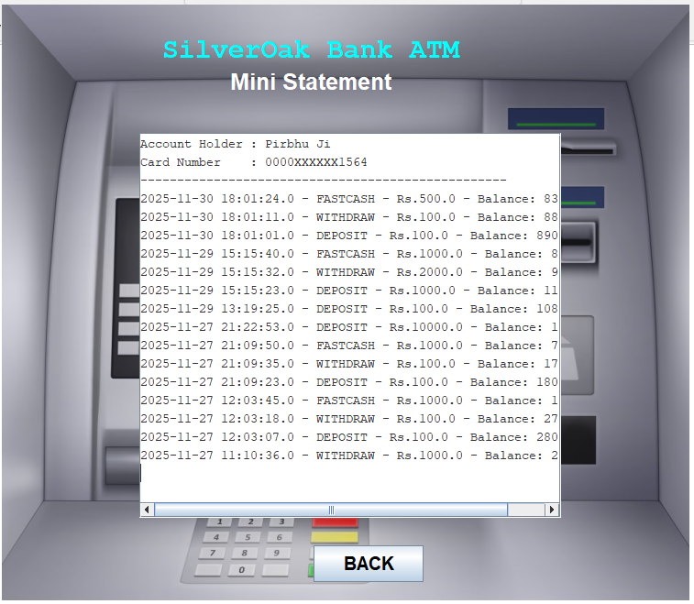

Screenshot 8–Pin Change Window
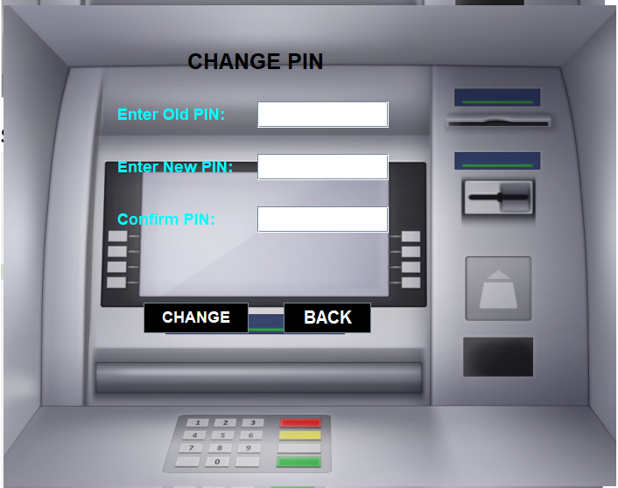

Screenshot 9 –Balance Enquiry Window
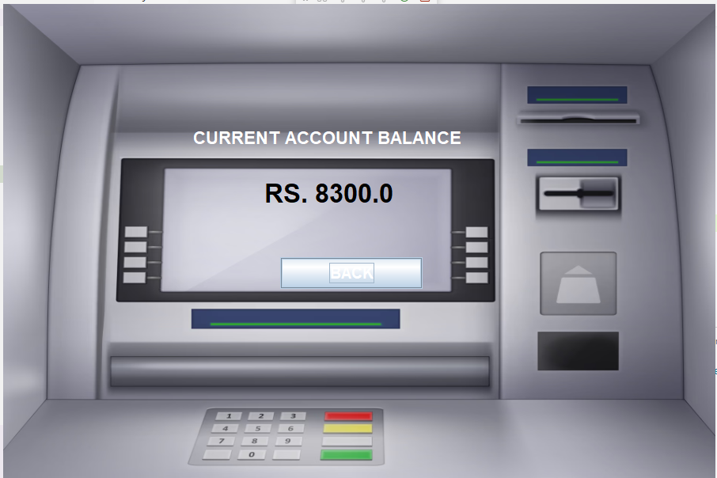

Screenshot 10 –Login Database Window
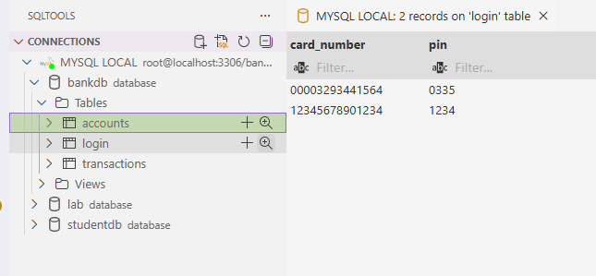

Screenshot 11 –Accounts Database Window
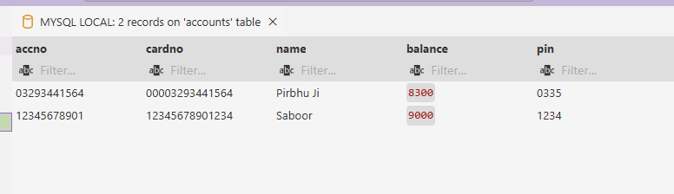

Screenshot 12 –Transactions Database Window
